**Lab 4**

**Exercise 1**

Design and develop a program that computes an employee’s income tax based on the following criteria:

If the gross pay is less than €50000.00, an allowance of €25000 is given, i.e. no tax is paid on the first €25000, (assume minimum gross pay is €35000)

If the gross pay is greater than or equal to €50000.00, an allowance of €20000 is given, i.e. no tax is paid on the first €20000.

A Single person pays 20% tax – code for single is ‘s’

A Married person pays 23% tax - code for married is ‘m’

The program should ask the user to enter their employee identification number( store this as a String), name, address, marital status, s for single, m for married, this should be stored as a char in the program, and gross pay. (All strings should be input using nextLine())

The program should then calculate and display the employee’s details, name , address, marital status, gross pay, net pay and total tax paid. Format the output using printf as shown in the sample output.

In order to improve security, after the previous calculations have been made, allow the user to enter a password and store it in the program. Allow the user to enter the password a second time and store that value, check if the two passwords entered are the same, if they are not the same , tell the user that the passwords are not the same.

Note: As you are reading in a String after a number (gross pay) you need to code an additional nextLine() to discard the end of line character.

**Sample Output**

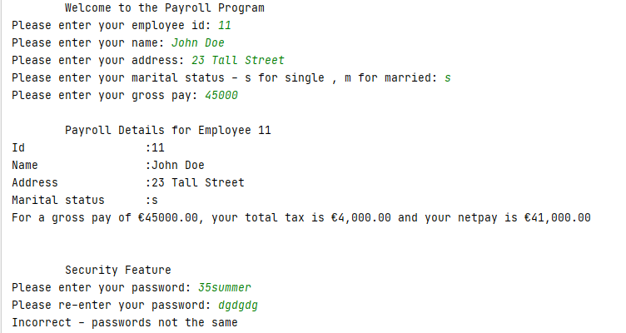

**Exercise 2**

An application inputs a purchase price for an item and an amount tendered and then displays the change in Euro coins, 50 cent pieces, 20 cent pieces, 10 cent pieces, 5 cent pieces and 1 cent pieces.

The two input values, item price and amount tendered, are entered in cents, e.g. 3580 for €35.80 and 4000 for €40.00.

Display the output in the following format:

**Purchase Price: €35.80**

**Amount Tendered: €40.00**

**Your change is: €4.20**

**4 one Euro coins**

**0 50 cent coins**

**1 20 cent coins**

**0 10 cent coins**

**0 5 cent coins**

**0 cents**

**Thank you for your business.**

**Note:** The purchase price and amount tendered are entered in cents (int) but should display with decimal points. If there is not enough money tendered the program should display a message “Not enough change tendered” and exit using System.exit(1).